## IMPORT/EXPORT

In the **Import / Export** tab, users are able to export either a standardized Continuity of Care Document (CCD) or a BlueButton (ASCII) file containing lab results and reports. The CCD is capable of being stored and displayed within the Microsoft HealthVault Personal Health Record (PHR). The BlueButton file enables patients to view the CCD in plain-text format.

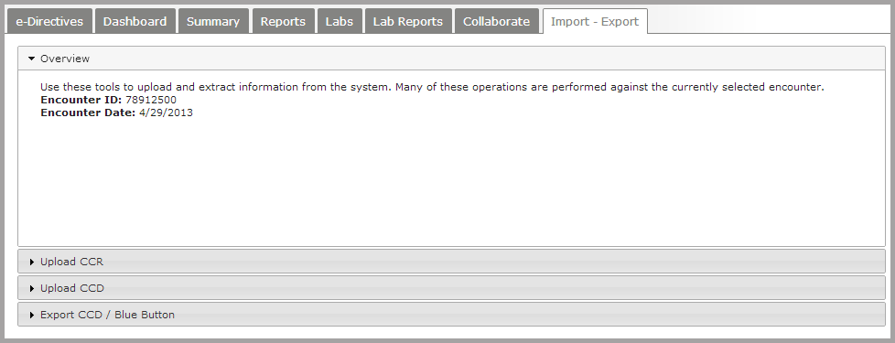

### Exporting a CCD

In order to export a CCD from the HIE to HealthVault, the patient must provide a valid HealthVault Direct Mail address (similar to **first_last@direct.healthvault.com)**. The patient must present this address; there is no alternative resource for retrieving the address.

Next, click on the **Export CCD / Blue Button** row to set export options.

Note: Export to HealthVault requires a HITSpC32 document type. This and all other default settings should not be changed. Optional password and email address should also be left blank.

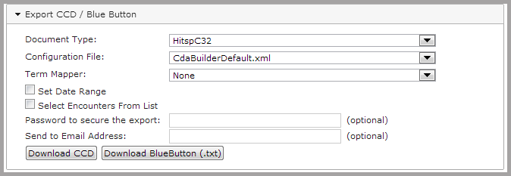

The entire patient record will be exported by default. If specific time periods or encounters are desired, the following options are available:

Check the box beside **Set Date Range** to export a specific time period.

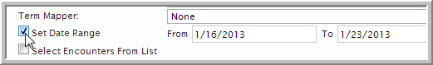

Check **Select Encounters From List** to export one or more encounters.

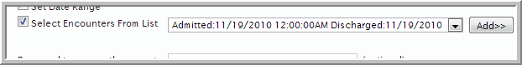

Select from the list of encounters and click **Add** to move the encounter to the export list.

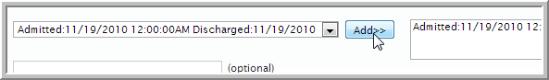

After any desired options have been selected, click the **Download CCD** button.

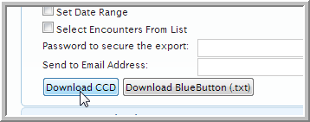

After download, a zip file with the patient’s name will appear in the default Downloads folder on your computer.

To attach and send the CCD, click the **Send Message about patient** link in the patient banner.

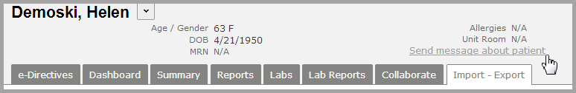

In the *To:* field, enter the HealthVault Direct Mail address provided by the patient. The Direct Mail address just entered will appear below the *To:* line.

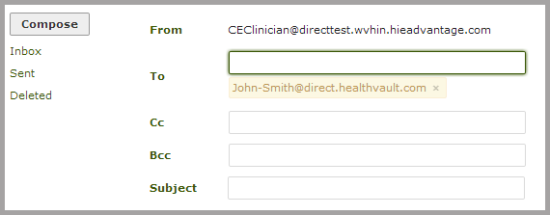

Next, click the **Attach** button at the bottom of the screen and select the patient’s CCD zip file from the Downloads folder on your computer. Then, click the **Send button**. It is not necessary to enter a Subject or message.

After logging into HealthVault, all individual data elements of the CCD, including all lab results and reports, will be available to the patient within the appropriate HealthVault display categories.

### Exporting BlueButton Files

Exporting a plain-text BlueButton file follows the same steps as export of a CCD, with the exception of the HealthVault address. After selecting date range and encounters, click **Download BlueButton (.txt)**. If you are downloading a .txt file to send to a patient who does not have a Direct Messaging address, be aware that files containing PHI should not be sent by unencrypted means.

Note: downloaded CCD zip files contain Protected Health Information (PHI) and should be permanently deleted from your computer after each CCD download and transfer.